

**Trimester: I/II/III Subject: Programming and Problem Solving**

**Name**: Krishnaraj Thadesar **Division:** 9

**Roll No.:** 109054 **Batch:** I3

**Experiment No.:** 2B

**Name of the Experiment:** Write an algorithm and draw a flowchart to convert a given decimal number into binary

**Performed on:** 16nd December 2021

**Submitted on:** 23rd December 2021

###### AIM: Write algorithm and draw flowchart to convert given decimal number to binary.

**OBJECTIVE:**

1. To understand importance of flowchart for any programming model.
2. To learn simple flowchart symbols and arrows to define relationships.
3. To understand and develop visual representations of flow of data.
4. To learn and understand the conversion of Decimal to Binary

**THEORY:**

1. Decimal to binary in C
2. Decimal Number

In the number system, each number is represented by its base. If the base is 2 it is a binary number, if the base is 8 it is an octal number, if the base is 10, then it is called decimal number system and if the base is 16, it is part of the hexadecimal number system

In the decimal number system, the numbers are represented with base 10. The way of denoting the decimal numbers with base 10 is also termed as decimal notation. This number system is widely used in computer applications. It is also called the base-10 number system which consists of 10 digits, such as, 0,1,2,3,4,5,6,7,8,9. Each digit in the decimal system has a position and every digit is ten times more significant than the previous digit.

1. Binary Number

A binary number is a number expressed in the base-2 numeral system or binary numeral system, a method of mathematical expression which uses only two symbols: typically "0" (zero) and "1" (one).

1. Algorithm

A finite set of steps that must be followed to solve any problem is called an algorithm. Algorithm is generally developed before the actual coding is done. It is written using English like language so that it is easily understandable even by non-programmers.

1. Flowchart

A flowchart is a diagram that represents a set of instructions. Flowcharts normally use standard symbols to represent the different types of instructions. These symbols are used to construct the flowchart and show the step-by-step solution to the problem.

1. Pseudocode

In computer science, pseudocode is a plain language description of the steps in an algorithm or another system. Pseudocode often uses structural conventions of a normal programming language, but is intended for human reading rather than machine reading. It typically omits details that are essential for machine understanding of the algorithm, such as variable declarations and language-specific code.

# PLATFORM: Windows 11 64 Bit

**INPUT:** Give any Decimal Number

**OUTPUT:** Binary Number

Algorithm:

Step 1: Start

Step 2: Declare the Variables bin, remainder, dec = 0 as integers.

Step 3: Print "Enter the Decimal Number on the Screen"

Step 4: Input the value Decimal Number from the user.

Step 5: Find the Remainder when Decimal number is divided by 2 and assign it to remainder variable

Step 6: Multiply Remainder by 10^i(loop variable) and assign it to binary

Step 7: Divide the Decimal Number by 2 and Assign it to itself

Step 8: Repeat until value of Decimal number becomes 0

Step 9: Print the value of the Binary Variable

Step 10: End

Pseudo Code:

int main()

{

int bin = 0, remainder = 0, dec = 0

printf("Please Enter the Decimal Number")

input(dec)

for (int i = 0; dec != 0;i++)

{

remainder = dec % 2

bin += remainder * pow(10, i)

dec /= 2

}

print("The Number in Binary is: %d", bin)

}

Flowchart:

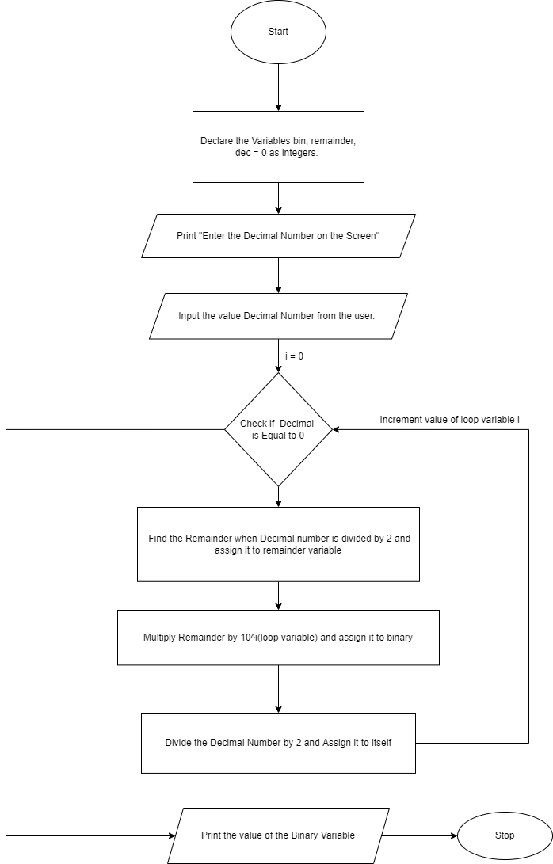

**CONCLUSION:** Thus we have learnt how to convert Decimal number into Binary with its algorithm and flowchart.

**FAQs:**

1. How do you convert decimal to binary?

Step 1: Divide the given decimal number by 2 and note down the remainder.

Step 2: Now, divide the obtained quotient by 2, and note the remainder again.

Step 3: Repeat the above steps until you get 0 as the quotient.

Step 4: Now, write the remainders in such a way that the last remainder is written first, followed by the rest in the reverse order.

Step 5: This can also be understood in another way which states that the Least Significant Bit (LSB) of the binary number is at the top and the Most Significant Bit (MSB) is at the bottom. This number is the binary value of the given decimal number.

2. How do you convert fractional decimal value to binary numbers?

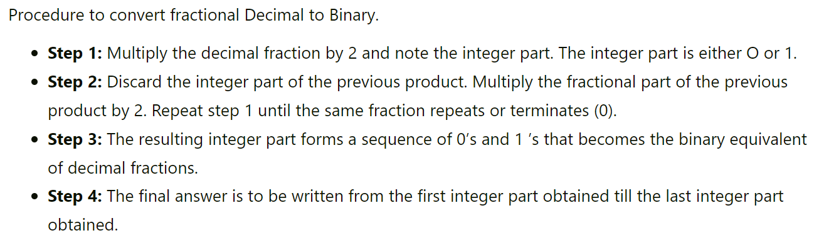

3. What is the decimal equivalent of the binary number 110?

The Decimal number 110 in Binary is 01101110

4. How do you convert binary to text?

Computers convert text and other data into binary with an assigned ASCII (American Standard Code for Information Interexchange) value. Once the ASCII value is known, that value can be converted to binary. In the following example, we take the word hope, and show how it is converted to binary that the computer understands.

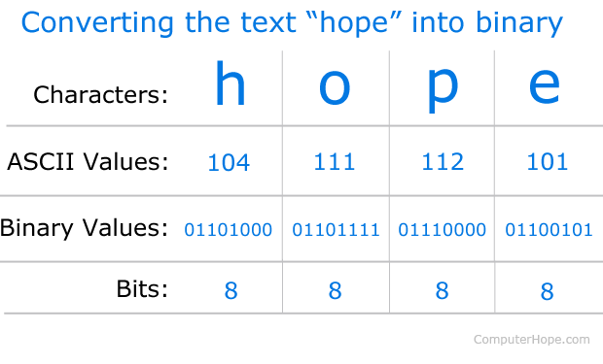

Let's take the first character h and break down the process. Once the letter h (in lowercase) is typed on the keyboard, it sends a signal to the computer as input. The computer operating system knows the ASCII standard value for h is 104, which can be converted by the computer to the binary value 01101000.

After the **h** is converted into binary, the computer can store and process the data as ones (on) and zeros (off). When storing this data, each character takes 8 bits (1 byte), which means to store "hope" as plaintext, it would take 4 bytes or 32-bits.

**How does the computer convert binary back into text?**

When the computer needs to convert the binary data back to human-readable text, it's the reverse of the previously shown process. For example, a computer may convert the binary 01101000 to the decimal value 104 which it knows is the letter h using the ASCII standard conversion. Hence, you see the letter 'h' output to your computer's monitor.

Given below is the ASCII Table:

